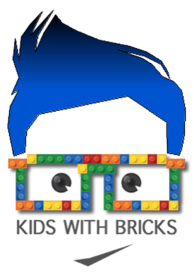

Dear Parents,

Kids With Bricks After School Club at St Joseph's Catholic Primary School

We are pleased to be able to offer our Kids With Bricks after school club running from 3:20-4:20pm every Tuesday for 5 weeks from 20th February 2024. This club is open for Years 1-5 and there are a maximum of 20 places available. The club is organised, administered and supported by Kids With Bricks Ltd, an external provider who deliver after school clubs across the whole of the UK.

As well as completing a range of exciting educational challenges, students will have the chance to work both individually and to work in teams.
As an added bit of fun, students from the club will also take part in a weekly inter-school competition where parents can vote for their favourites and points are won for the national leader board.

BOOK ONLINE!
The club costs £3.99 +VAT per child per session and is paid for termly in advance. All club places are reserved and paid for online. Just go to www.kidswithbricks.com to book your child’s place.

*Tickets go live on Wed 7th Feb at midday!

Any problems please contact us on 01633 383211 or bookings@kidswithbricks.com
Kind regards,
John Gallacher

