Information for Parents / Carers – Combined Level 1 & Level 2 Bikeability Course

WHAT IS BIKEABILITY?

Bikeability is the national cycle training programme funded by Active Travel England. Courses are designed to give participants the skills and confidence to make journeys on the road by cycle. All courses are delivered by fully qualified instructors who hold an Enhanced DBS and are Safeguarding and First Aid trained. For more information on Bikeability please visit Bikeability.org.uk

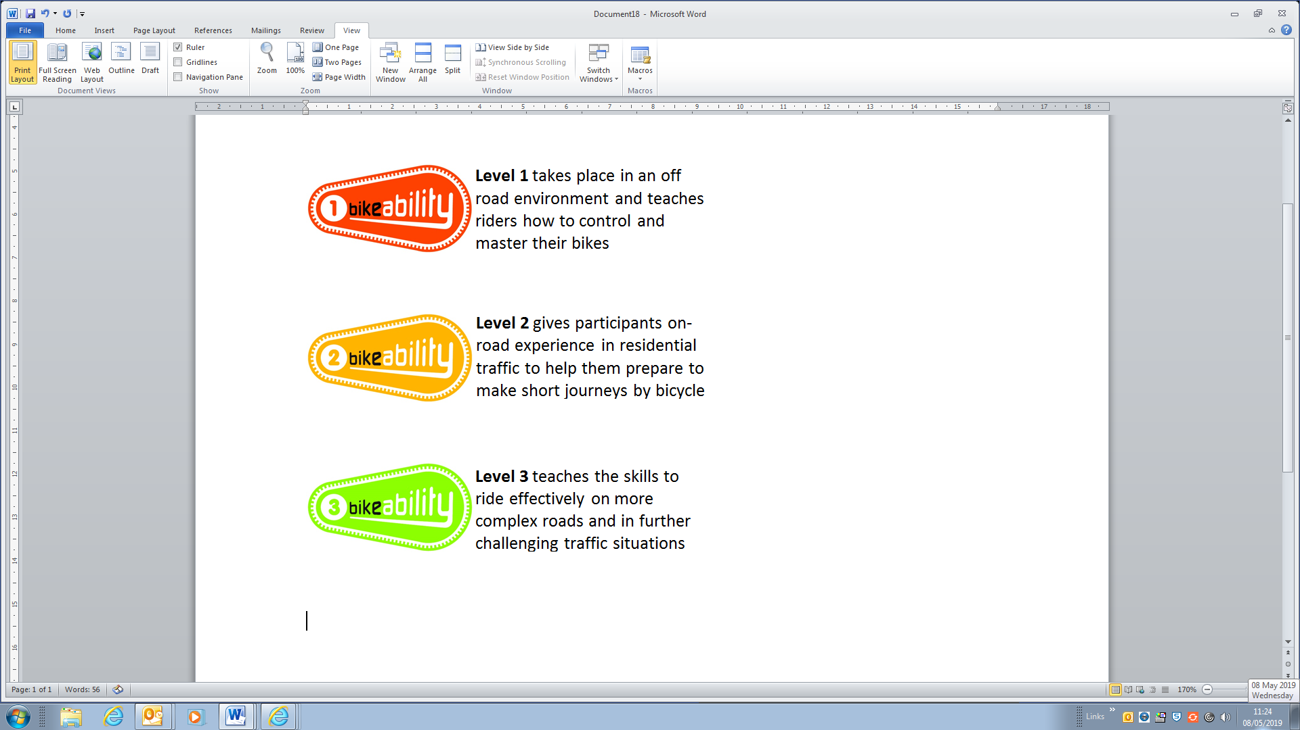

*Please note that to take part in a Level 1 or Level 2 Bikeability course, children must be already able to ride a bike.

Training is delivered on behalf of the school by Gloucestershire County Council, Shire Hall, Gloucester, GL1 2TG. (01452) 425926 bikeability@gloucestershire.gov.uk

HOW TO BOOK
Bikeability places are limited and places will be booked on a first come basis. Please complete and return a consent form (below) to the school as soon as possible. The cost of the course is £10 per child (unless eligible for free school meals).

Parent / Carer Consent Form
COURSE INFORMATION | WHAT WILL YOUR CHILD NEED?
- Bikeability Levels 1 and 2  - Dates –  - Cost – £10 (unless eligible for free school meals) | • A complete consent form (see below)  • A roadworthy bike without stabilisers (see ABC checklist above)  • A helmet  • Suitable clothing for the weather conditions

I understand that (please tick):

- I agree to my son/daughter taking part in cycle training.
- My son/daughter can already ride a bike (you child will be unable to do L2 Bikeability if they cannot ride a bike).
- The instructors may refuse to train my child if they deem his/her cycle to be un-roadworthy.
- It remains my responsibility to ensure my child does not ride an un-roadworthy bike and if I am in doubt as to whether a cycle is roadworthy I should seek the advice of a professional mechanic.
- Instructors may at any time refuse to continue to train my child if his/her behaviour or cycling ability is deemed unsuitable.
- Gloucestershire County Council will not be responsible for any injury or liable for any loss or damage to participant’s cycles and other belongings.
- It is recommended that trainees wear a helmet and it may be a requirement of the school.
- I agree to encourage my child to practice between each session and after the completion of training.
- I consent to the Bikeability instructor ‘adjusting’ my child’s helmet if required, however I confirm they are not responsible for the physical condition or appropriate fitting of the helmet.
- I consent to qualified instructors administering first aid to my child if required.
- I understand that pupil data collected will be used to support the delivery and monitoring of training sessions/courses.
- I understand that aggregated and anonymised data will be shared with Active Travel England for monitoring purposes.
Please see https://www.gloucestershire.gov.uk/council-and-democracy/data-protection/service-specific-privacy-notices/ for further details about how we use and share your and your child’s data.

Full Name of Child:

Are there any medical/ educational needs we need to be aware of?

I confirm that I have read all the information enclosed in the ‘Parental Consent Form’ and consent to my child (or the above child for whom I take responsibility) to take cycling lessons and related activities, which may include cycle maintenance as well as riding on the public highway. I understand that this information is retained by my child’s school and used to ensure my child is eligible to undertake Bikeability training.

Signed (parent/carer):

Date:

Important Information
PRE-COURSE BIKE SAFETY CHECK
Before bringing your child’s bike to school for the course please check the following:
Ensure both your front and back brakes work properly
Clean and oil your chain regularly to ensure that it is running smoothly
Run through all your gears
Check both your front and back tyres are pumped up
Make sure your handlebars, wheels and saddle are fixed on tight
Remember your…
A
Air
B
Brakes
C
Chain
before every ride

Collection of Ethnicity data
From September 2021 Active Travel England have asked that Schools collect and report on the ethnicity of children attending Bikeability sessions for equalities monitoring purposes. This data will be anonymised when it is sent to Active Travel England, but it does mean that your child’s ethnicity will be recorded on Cycle Ready, our internal booking management system. Please note that your child’s enrolment onto the Bikeability course will not be affected if you choose not to consent to this.

Do you consent to your child’s ethnicity data being processed in the above manner Yes / No

Privacy Information
Any information you provide will be treated as confidential and in accordance with UK data protection legislation. We will keep and use your information for booking, organising and conducting road safety cycle training as part of the Bikeability Scheme. With your full consent, we may also photograph and/or film your child taking part in the scheme to help promote Bikeability. The information provided may also be shared with the Department for Transport, and be used for the wider purpose of providing statistical data used to assist with monitoring provision and applying for funding where relevant. Any information provided will not be shared with or passed on to any other third party. For full information on how we use and your child’s information, and how to exercise your rights under the Data Protection Act, please visithttps://www.gloucestershire.gov.uk/council-and-democracy/data-protection/service-specific-privacy-.

