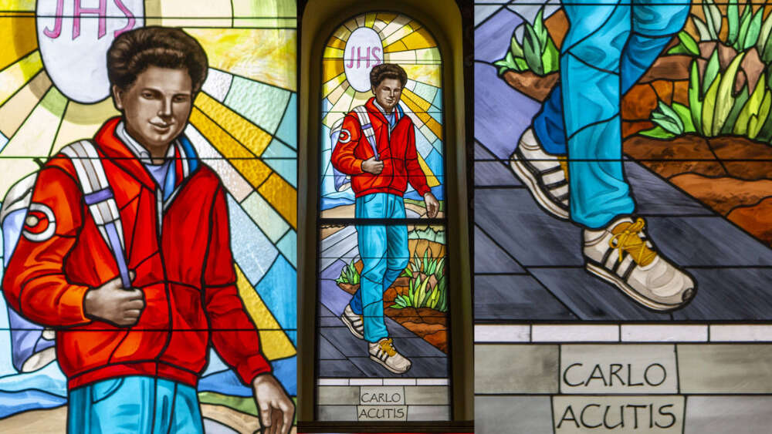

What is a Saint?
For Catholics a saint is someone just like us, everyday people, but they made extraordinary choices to love and serve God throughout their lives and are now in Heaven.
One such person is Carlo Acutis. He is a modern-day saint. Often pictured in jeans and a polo shirt, he is immediately relatable to today’s youth because he looks like today’s youth. He loved God, praying the rosary, and going to mass. He even got his whole family attending daily mass with him.
Carlo also loved technology and video games! Even though he loved his Playstation, he restricted his playing time as a spiritual discipline. He was very skilled in programming and used his gift to create a website dedicated to sharing stories of Eucharistic miracles. Carlo was also noted to be a defender of children who were getting teased at school.
Carlo Acutis died in 2006 of leukemia at the age of 15 and was beatified on October 10, 2020. He is the patron saint of computer programmers and youth.

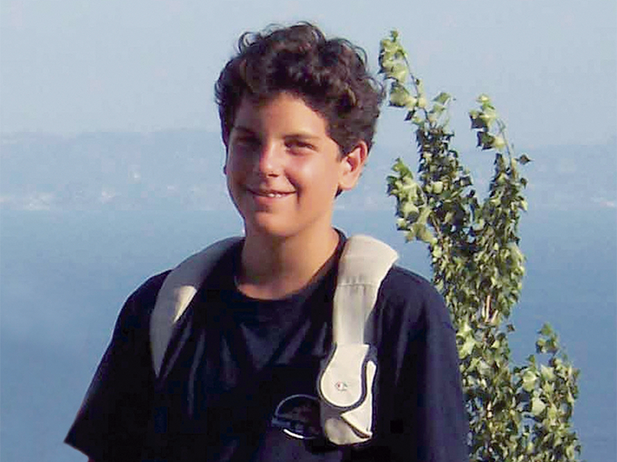

On the 7t^{h} September 2005 Carlo Acutis will be canonised by Pope Leo XIV. He is the first person to be made a saint this millennium.
There are various stages to go through to become a saint and can take many years.
The Vatican named him Venerable Carlo Acutis for living a good and faithful life. After his death it was noted how holy he was, even as a teenager.
He became ‘Blessed’ by Pope Francis in 2020 after a miracle was attributed to Carlo of a little boy in Brazil who was healed from a serious illness after his family prayed to Carlos. A second miracle needs to be confirmed for a person to be canonised as a saint and this happened after a university student who suffered a brain injury recovered after praying for Acutis’s intercession.
He died on 12th October 2006 In Italy aged 15 years old. He is buried in a glass coffin in Assisi’s Sanctuary of the Renunciation wearing denim jeans and Nike trainers. Visitors flock to see him daily.
Before he died Carlos said “I am happy to die because I have lived my life without wasting a minute on those things that do not please God.”
How can we be like Carlo?

God, Our Father,
Thank you for giving us Carlo,
as an example for all young people,
and a message of love for everyone.
You led him to love your Son Jesus in the Eucharist,
his “Highway to Heaven”.
You gave him Mary as his loving Mother, who he met in the Rosary.
You showed him how to love and help the poor.
Grant for me too, by his intercession, the grace that I need ...
and fill us with joy by placing Carlo among the Saints of your Church,
so that his smile may shine again for us in the glory of your name
. Amen

What Made Carlo Special?
- He went to Mass every day and prayed often.
- He helped the poor with food and clothes.
- He stood up for kids who were bullied.
- He once said:
“The Eucharist is my highway to Heaven.”
Even though he was young, Carlo used his tech skills and kindness to do big things for God!

💔 When Did He Die?
Carlo got leukemia (a kind of cancer) and died in 2006 when he was only 15 years old.
But before he died, he said:
“I’m happy to die because I’ve lived my life without wasting even a minute on things that don’t please God.”

🕊️ How Did He Become (Almost) a Saint?
The Church has a special process:
- People noticed how holy he was, even as a teen.
- He was called Venerable Carlo Acutis for living a good and faithful life.
- A little boy in Brazil was healed from a serious illness after his family prayed to Carlo. It was a miracle!
- Because of that miracle, Pope Francis made him Blessed Carlo Acutis in 2020.
- A second miracle is being checked right now. If it’s approved, he will be declared a saint

