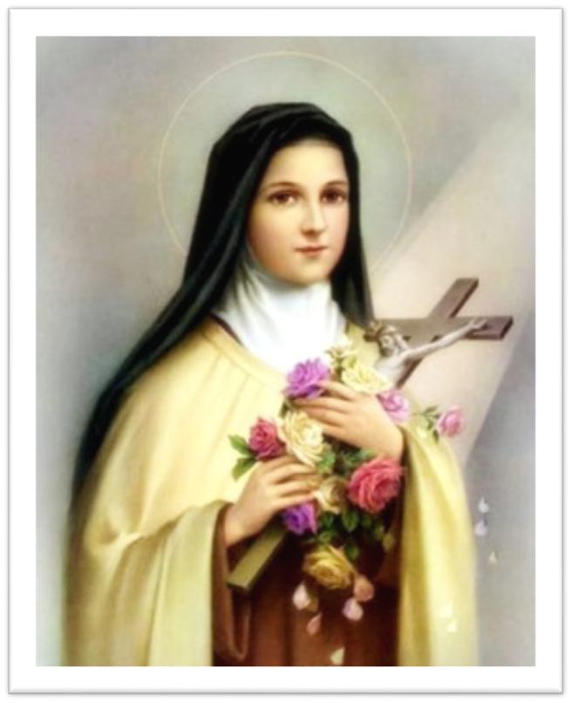
With St Therese as our guide we do little things with much love to make a big difference for everyone.

St Joseph’s Catholic Primary School

Diocese of Clifton

Inspiring everyone to REACH through
Faith, Hope, and Love

Front Street, Nympsfield, Stonehouse, Gloucestershire GL10 3TY
Telephone/Fax No: 01453 860311 Email: SLT@st-josephs.gloucs.sch.uk
Website: www.st-josephs-nympsfield.com

Headteacher: Mrs Clare Howells

Dear Parents and Carers,

Welcome back to the Summer term – I hope you had a very relaxing Easter break.

As we begin the new term at St Joseph’s, I look forward to exploring some new topics with the children. We will be learning all about life cycles in Science, working with clay in Design and Technology and exploring the human and physical features of Zambia in Geography. Overleaf is our Topic Web for this term.

Please see below the details you will need for the coming weeks:

PE
This term, Swimming will be part of our PE lessons which will be on a Tuesday afternoon. Please make sure your child arrives in their school PE kit on Tuesdays and Fridays.

Homework
Homework will continue to be set on a Friday and due in on a Wednesday. Please note that homework that is not handed in on this day may not be marked. All homework will continue to be set on TEAMs. Please do speak to SLT directly if you have any difficulties in accessing your child’s TEAMs account.

Reading Points
I have been thrilled to be able to award more reading badges over the last term – it just shows how dedicated your children are to reading! Please do keep reading with your child as much as you can (and don’t forget to record your reading sessions in your child’s Reading diary). We will continue to award your child with 1 Reading Point if they read at least 5 times at home in the same week.

It has been wonderful to have continued support from our parent readers. I would like to express my gratitude to them for providing your children with these invaluable opportunities. If you are interested in volunteering as a parent reader this term, please do contact Mrs Guoite directly either after school or via the SLT email.

Just a couple of reminders:
- Please ensure that your child brings their reading diary and reading books into school with them every day. Your child will have their reading books changed each week, but we cannot change them if books are not returned.
- Please ensure that your child brings a coat with them to school each day.
- As the weather starts to get warmer, it is ever more important that your child brings a water bottle to school every day.
- As we continue to have Outdoor Learning lessons each week, please ensure that your child has a pair of wellies in school. The children will be going out in all weather and will need to be appropriately dressed.

Thank you for your continued support as we start the Summer term. Fingers crossed we have some sunshine!

Yours sincerely,

Miss Rebecca White
Year 2 Teacher

